www.LinkUpStudio.com.ua mail: info@linkupstudio.com.ua
tel.: +38 (067) 733-14-23
+38 (093) 420-11-20 +38 (066) 550-36-52 +38 (032) 253-03-95



EDIAB1st Phase alfa-version
2015

General Information

VISION
The EDiaB (Economic-Development-in-a-Box) portal is designed to provide communities who are interested in growing their economy, a single, easy-to-use, in-expensive, one-stop web solution that promotes their community to outsiders, increases community, business and service offering awareness, and facilitates information exchange and collaboration among local residents and entrepreneurs, as well as tracks and manages the economic development process for economic development professionals.

FEEL
It will be very very easy for anyone to use without any help. All pages and content will be self-explanatory. The design will be clean, cool, simple, smooth and modern, but without being so hip that it excludes anyone.

FUNCTION
The function will be simple, clean, quick and terse, without unnecessary clutter, click actions or verbiage.

Modules

EDIAB (1st Phase alfa-version) will contain 12 main modules:
- User profile module
- System functionality (language support, and background process)
- Admin functionality
- Home page
- Community branding page
- Work page (vacancy & resumes)
- Biz directory
- Real estate functionality
- User product features
- Success Story Documentation
- FAQ
- Community calendar

General use case diagram

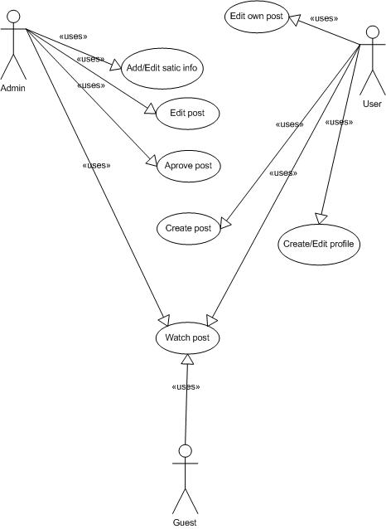

Main post categories
For the alfa version PHASE 1 we wind out 6 main categories, every of it would have their own sub categories and tags:
- Vacancy
- Resume (talent)
- Business (entrepreneurship)
- Real Estate
- Products
- Event

User profile module
Module that contains everything that connected to the register user functionality.
Main features:
- Registration
- Profile editing
- Forget password functionality
- Newsletter to neighbors
- My POSTS
  - My vacancies
  - My Resume
  - My Products
  - My Real Estate
  - My Companies
- Create new post short cut
- Sorting + search + filtering through posts
- Products status (connect to My products functionality)

General page view
General page view will contain all info describing next.

Vision template:
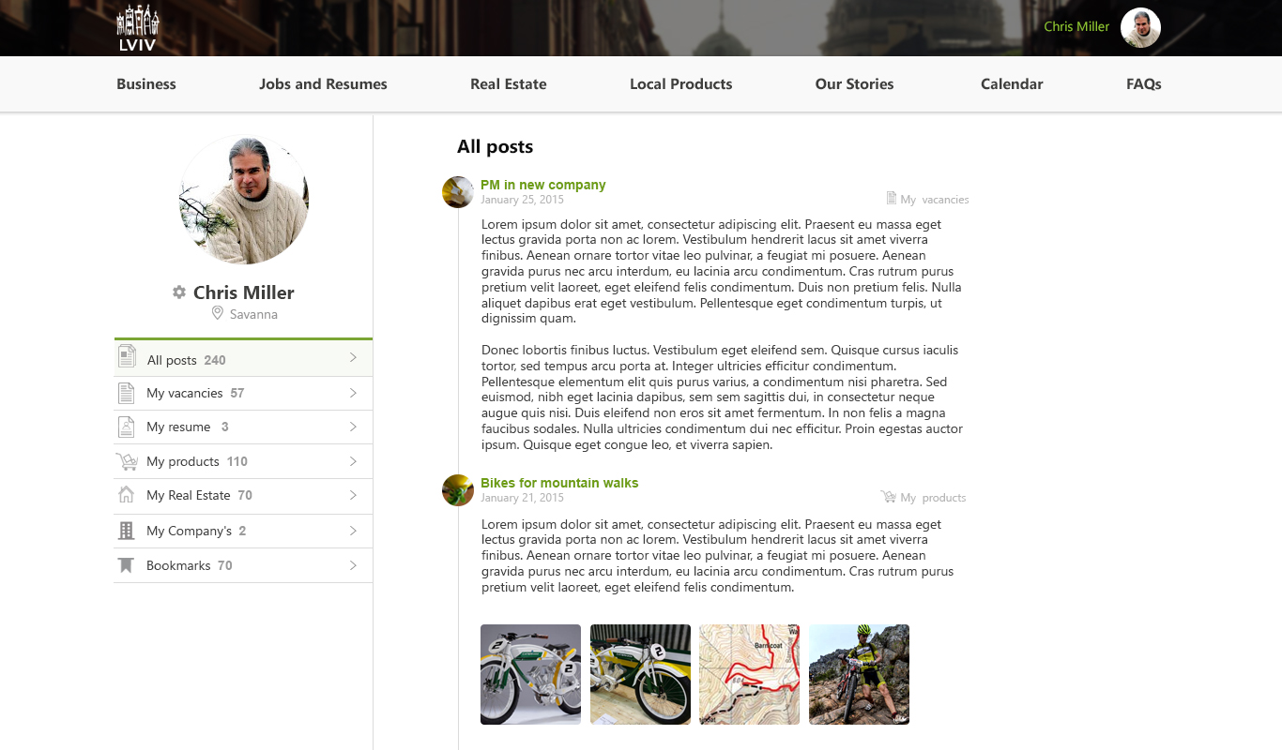

Registration
Page where guest can enjoy the community.
Registration is available through 3 socials network: facebook, google+ , twitter. Also like simple registration through email address.
Info to enter for registration:
- Name
- Age
- Sex
- Neighbors
- City
- Phone
- Location (Address)
- Image (avatar)

Sequence Diagrams
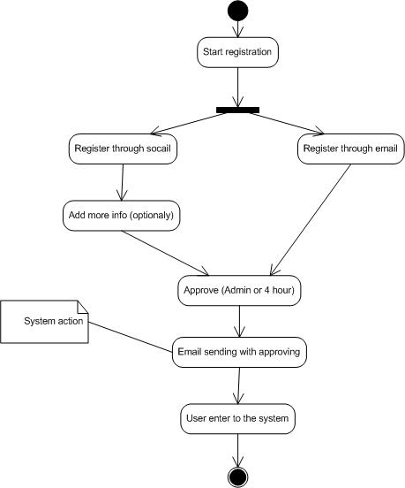

Profile editing
Page in which user can edit his own data, change photo and all other info

Forget password
Functionality which allow recovering password if needed. Standard option.

Neighbors newsletter
When user will register in, he would advise to fill in two email address with his friend emails and system going to message that friends about our user registration in portal. Functionality is optionaly

My Posts
Every user can create his own job, upload resumes, create companies etc. so he need to have functionality to watch all of it attraction.
My post functionality will allow to see all your recent activity and created posts.

Create new post short cut
Function that allows creates posts direct from user profile page.

Sorting + filtering + Search
In a few time post activity will be to much, so it should be a function which allow user to find posts in every category he want or generaly.

Product status
When user will create product to sell. He should have functionality to change it status (sent, reserved etc.)

System functionality
Whole system should have some general parameters and functionality which should be created in the Core we find out two main things:
- Language support
- Data base archive

Language support
System will allow to create own vocabulary of words to make admin interface and also user interface be multi language. Its mean that admin can fill in language which he want to make system support. However user should enter info on all that languages which mean double work.
BUT here is an opportunity for communities or us to offer translation functionality.

Data base archive
If we want to make system save it should be some archive functionality and system should backup itself. In our opinion once per day will be enough. Also functionality to standup copy of database for concrete day.

Admin functionality
Functionality for admin part. Contain such blocks:
- System mail template editing
- Add sub categories by post
- Add tags by categories
- Approve of members
- Approve of post by categories
- Changing of elements on main page
- Language supporting
- Changing of static pages (FAQs etc.)
- Backup interface
- Modules order
- Section with bugs message
- Section with wish list
- Currency functionality
- Add/edit event functionality (for calendar)

System mail template editing
There are a few email template in the system: registration email, approve email, forgot password, newsletter etc.. Administrators of community will allow to set up any template there are wanted before sending. Also allow to fill in image and others.

Add sub categories by post
Admin will have functionality to add subcategories to every type of post. For example for Real Estate it can be: flat rooms, cottage, buildings, garage etc.

Add tags by categories
Every sub categories can have their own tags. Admin will allow to add this tag for every sub category.
Main schema of categories (vacancy example):
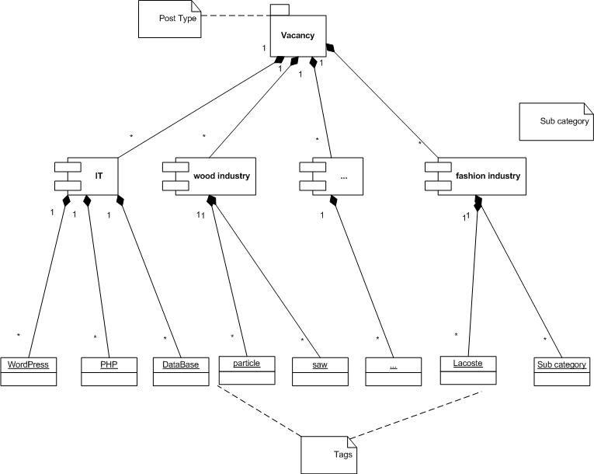

Approve of members
After registering in a system admin can approve the member if he would not, member will approve automatically within 4 hours.

Approve of post by categories
Admin can see all post by all categories and can BAN it or approve if post will not approve within 4 hours it will approve automatically.

Changing of elements on home page
Admin can change some main elements in the home page: picture, info graphics, FAQs question, etc.

Language supporting
Admin can choose how much and what exactly languages will support at the system

Changing of static pages
Website may have a few static page for example some community want create for themselves some exact page.

Backup interface
Interface for backup functionality.

Modules order
EDIAB should be module system so it should be functionality to order some module direct from admin panel

Section with bugs message
Section where admin can read all the bug message from users, before it send to programmers.

Section with wish list
User can add their wishes of improving of website all that wishes will be listed in this section.

Currency functionality
When user will list products in Prooducts section some communities may have a few currencies admin will allow to add currency, make it active or edit.

Add/edit event functionality (for calendar)
Functionality to work with calendar. Add event, upload its photo, make description, set up the place.

Home page
Main landing page which user will see first time go to the website.
It should have beautiful and attractive design also with possibility to change it from administrative part.

Design template:
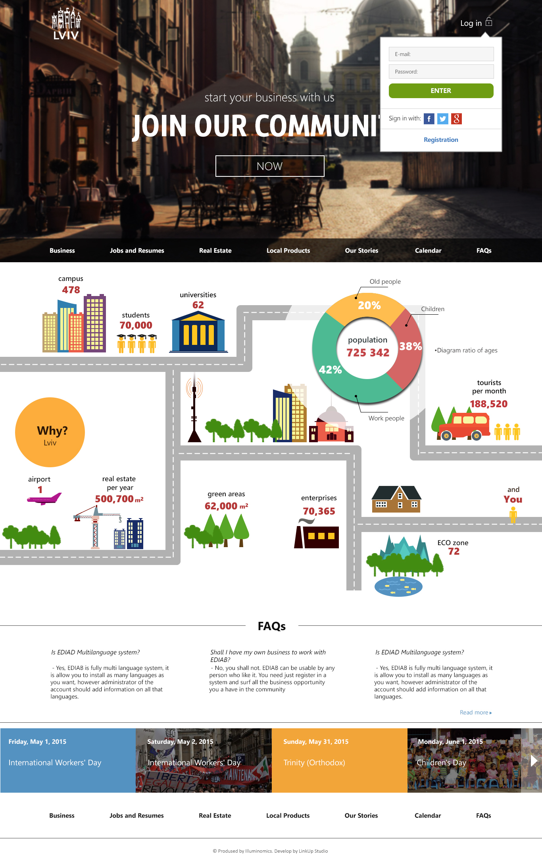

Community branding portal
Page with history and information about community.
To make it universal it would be like constructor page with 4 main blocks:
- Text
- Slides
- Graphic
- Video
Admin can use it in any way he want so every page will be unique, attractive and beautifull.
Also graphic part will be universalized so admin need just input data, and system will draw diagram by itself without designer.

Work page (vacancy & resumes)
Page with talents and vacancies in the community. Main functionality:
- Vacancy form creation
- List of vacancies
- Page of exact vacancy
- Preview of vacancy before posting
- Resume sending
- Related vacancies functionality
- Bookmarks for resume
- Bookmarks for vacancies
- Compare list of vacancies
- Compare list of resume
- Resume form creation
- Search through resumes
- Page of exact resume
- Related resume
- Sending form (connect to employer)

Vacancy form creation
Page where user can create vacancy. Every vacancy has such attributes:
- Category
- Salary
- Education
- Type of employment (full time, part time)
- Experience of work
- For student (checkbox)
- For pupils (checkbox)
- Company (optionally if vacancy connected to some business)
- For immigrants (checkbox)
- Contact info
- Tags
- Status (open/closed)
- District of city
Vacancy is added to data base, every vacancy is tagged and categories.

List of vacancies
List of all vacancies at website. With possibility of selection categories, filter and searching.
List will be made with pagination which mean upload new page after selection.
Filter will use all parameters listed in the “Vacancy form creation” section.

Page of exact vacancy
Page with full description of the vacancy and possibility to send resume.

Preview of vacancy before posting
Preview vacancy before view. Short view and long description view and possibility to go back or to post a vacancy.

Resume sending
Form with possibilities to send new resume or attaching already existing. If user do not registered he should register in system and then send the resume.

Related vacancies functionality
Block in the page of exact vacancies where user will find information about related vacancies relation will find by parameters of vacancies.

Bookmarks for resume
Bookmark which user can do on resume to check it after. Resume Bookmark will stored in profile page.

Bookmarks for vacancies
Bookmark which user can do on vacancies to check it after. Vacancies Bookmark will stored in profile page.

Compare list of vacancies
User can add vacancies to compare it before each other. Comparation it is just the list of vacancies in table form. Where user can have more comfortable view of vacancy. So NO functionality of advising
OPORTUNITY: in beta version it can be artificial Intelligence advice functionality

Compare list of resumes
User can add resumes to compare it before each other. Comparation it is just the list of resumes in table form. Where user can have more comfortable view of resume. So NO functionality of advising
OPORTUNITY: in beta version it can be artificial Intelligence advice functionality

Search through resumes
Possibility to find resume with right search parameters. For search will be using the same parameters that user can enter filling in resume.

Page of exact resume
Page where user can open end see all the details of resume. And possibility to contact with owner of this resume.

Related resume
Block of Resumes which shown on the Exact resume page and related by few parameters. NO functionality of advising.

Sending form (connect to employer)
Form where user can wright to employer for contact through email. So in result no one see exact addresses.

Biz directory
Issue with list of companies of the community with main info about it. Main functionality:
- Creation of company
- List of companies (with search)
- Company exact page
- Company vacancies
- Review about companies (from other users)
- Gallery of company
- Company partners
- Location

Creation of company
Functionality with possibility to create your own company.
Main fields:
- Name
- Address
- Contacts
- Logo (optionally)
- Tags
- Video (optionally)
- Social links (optionally)
- Numbers of workers (optionally)
- Link to website (optionally)
*OPPORTUNITY: If people leave fields Logo or website link empty we can offer them developing of such products.

List of companies (with search)
List with all companies with possibility of searching and filtering through companies.

Company exact page
Page with description and presentation lawyer of company. Page will present company with it description, logo, gallery etc.

Company vacancies
In the exact company page will be a block with vacancies of company which they don’t deny to show.

Review about companies (from other users)
To make understand is that company trustable or not users that register in the system can leave their review about the company. All review should be checked by admin without 4-hour delay. (It’s very important).
Except just writing review user should pass small test by parameters to make mark for the company maximum realistic. So user should pass a few steps.

Gallery of company
Photo of company or their entertainment. Logos and other material to upload for making someone use them.

Company partners
List of partners with whom company are working.
*OPPORTUNITY: When people will put on their profile they will put info about some other companies.

Location
Possibility to add location directly on multimedia map.

Successfully story documentation
Page where user with access rights can create their own story documentation. Functionality is the same as community branding portal but with user interface for members.

Real estate functionality
Functionality to find places to rent or by in the community.
Main functionality:
- Page of exact object
- List of objects with search and filtering
- Archive of objects
- Compare List
- Real Estate Bookmarks

Page of exact object
Page with description of objects parameters it can have:
- Type (buy, rent by days, rent for long time)
- Photos (gallary)
- Type of property
- Price
- Square
- Map (Location)
- Included services (for rent per day)
- Numbers of flour
- What flour
- Tags
- Name
- Description
- Comments
- Area of city
- Restriction (for example “no dogs”)

Search and filter through list
Possibility to find object that user are needed. Filtering are making using parameters listed above.

Archive of objects
Possibility to add project to archive, so object its not available right now but it was before.

Compare List
List for compare different objects. Table listed all parameters.

Real estate bookmarks
Bookmarks that user can add to his profile page and then view after that.

FAQ
Page with most common questions. Instruction guide for all website. Contain:
- Adding of questions form
- Selection of parent category
- Tags to questions
- Search (using sfincs)
- Send new question form

Adding of questions form
Form where user can add new question and also add answer for this.

Selection of parent category
Possibility of question categorization. So any question can have category and sub category to make it easier for user to find

Tags to questions
Functionality of tag adding to question. Every question has tag by which it can be found.

Search (using sfincs)
User can search through FAQs using technology called sfincs (see stackoverflow) .

Send new question form
If user didn’t found the right answer in the FAQ list he can add his own. But while will add question sfincs will try to find best fitting answer for him. So part of request will finish before start.

Local product
Page strongly connected to biz directories. Actually that is a possibility to describe product and offers that company have.
Main functionality:
- Creation product form
- Connect to author
- Categories

Creation product form
Form to add new product with parameters that can be listed:
- Name
- Price
- Possible configuration
- Tags
- Image
- File

Connect to author
From with possibility to to author and connect without opening of emails or direct contact data.

Categories
Functionality that allows user to add products in categories to make it more sortable and easy to find (pre function of shopping male store)

